10. Tuning of autoISF settings for Full Closed Loop aided by the Emulator V.2.7 for 301

Please note that with autoISF you are in an early-dev. environment, where the user interface is not optimized for safety of users who stray away from intended ways to use. Good safety features exist, but these are only as good as the development-oriented user understands and implements them. This is not a medical product, refer to disclaimer in section 0

Available related case studies:

Case study 10.1:

Based on older autoISF and older Emulator versions, examples from emulator use can be found in case study 6.2, in case study 4.1 (last pages there), and case study 8.2
10.1 Installing the Emulator on your PC
10.2 Analyzing loop decisions in logfiles
10.3 What-if analysis

You can set up and tune the system for full closed loop as described in previous sections. Doing this by frequently analyzing screenshots that must be taken in real-time of the AAPS SMB tab is tedious, however.

More elegant and precise tuning can be done with a special evaluation software for the AAPS logfiles, by using the Emulator.

In the Emulator, you can see in tabular and graphical form, which autoISF component, and other settings, contributed to SMB values that determined the glucose curve.

Note that iOS based variants of autoISF (Trio or iAPS) can not use the Emulator. Refer to section 11.3.

10.1 Installation of the emulator on your PC

10.1.1 First download QPython 3L onto your PC (from Google Playstore).

Then download from: https://github.com/ga-zelle/APS-what-if/blob/A3.2.0.4_ai3.0.1_dev/software :

each of these 5 py resp. config. files. To do this, you must press, for each one, here
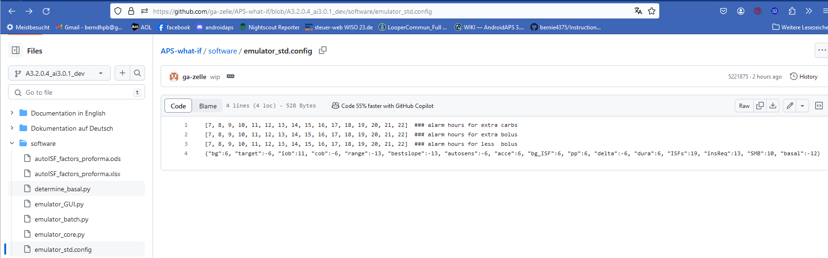
Always make sure you use the files from the branch with the same version number as your AAPS version (in the example above: These files will work with AAPS dev version 3.2.0.4 with autoISF version 3.0.1); (the dev connotation is temporary). Always keep your AAPS x autoISF and also the emulator related files up-to-date!

    - Retrieve these 5 downloaded files on your PC (list of recent downloads), and shift them into a folder in which, or neighboring to which, you also keep your AAPS logfiles. (These you must copy about once a week from your phone to this file on your PC)-
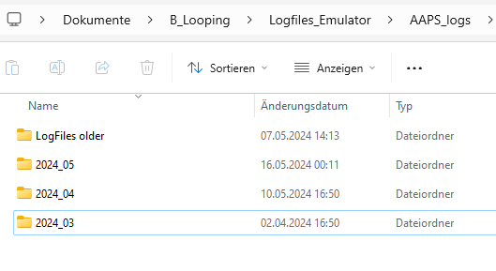

My folder structure for Logfiles and Emulation on the PC has (three) monthly folders that I most likely will look at, plus one folder with data from previous months and years.
Neighboring the AAPS_logs is the Emulator file where the 5 downloaded files went:
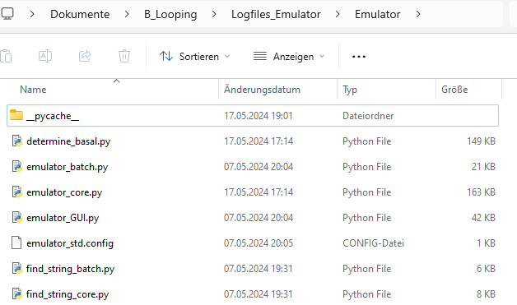

    - One of these files is “emulator_GUI.py“
- Create a link to it
- drag that link onto your desktop
- Name it something like Emulator start.

    - Repeat steps 10.1.1. and step 10.1.2. for 2 more py files from https://github.com/ga-zelle/Scan-APS-logfiles/blob/main and download also these:
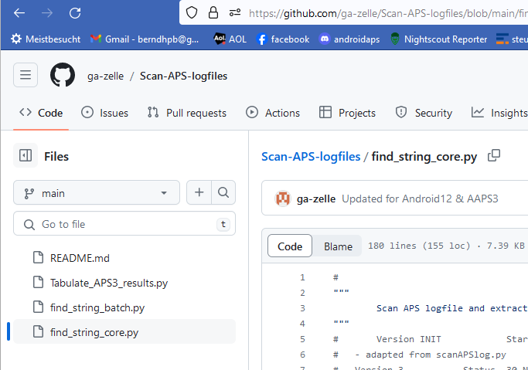
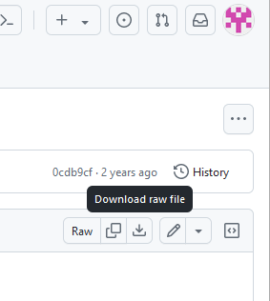

Include these in your Emulator file (as in example shown on previous page).

  - Read and analyze logfiles with help from the emulator

10.2.1 Set up a “no change” .vdf file.

It is just empty in the lines that would define any change to be investigated.
Note: for “what-if” analysis, entries will be made ( in a second vdf later, see section 10.3 )
To do this, just open Notepad++ (from list of all programs on your PC). Store that in a file of your current emulator project you are about to start (see my storage path in top line here)
The no change .vdf should look like something like this:
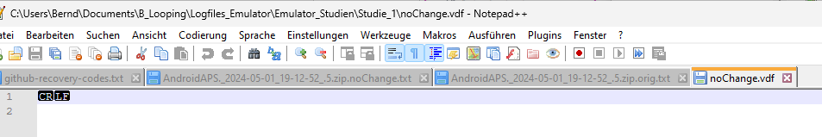
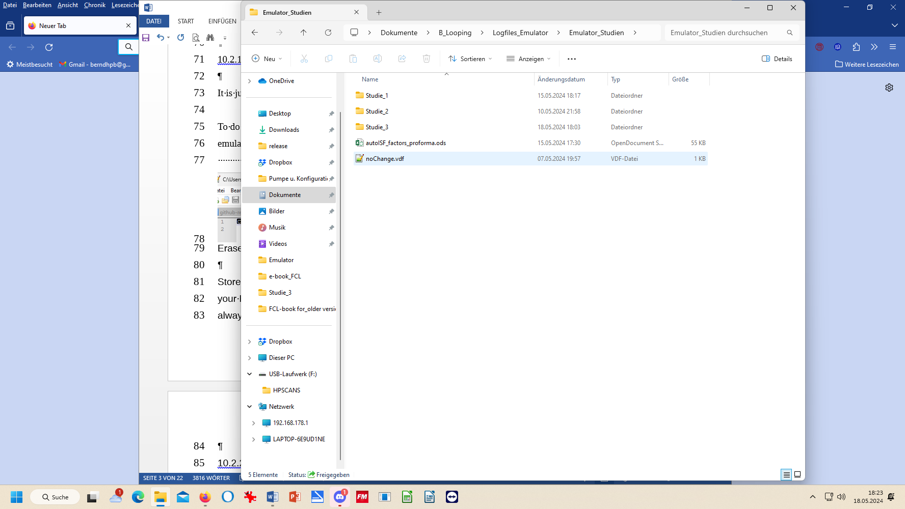
Erase any entries after CR LF and also in lines 2 ff, if any

Store this noChange.vdf in your Emul.-Studies file (neighbors your Emulator and Logfiles files). From that position, you always make a copy and paste into each Study_1 …_n
<- regarding this, see section 10.3.4
10.2.2 Locate relevant logfiles

Make sure you have the AAPS logfiles that you want to analyze in an immediate-neighboring file to your Emulator-- and to your Emulator_Studies- files (File structuire as suhggested and shown above).
Copy (not: move!) your noChange.vdf (see above) also into your Study file (must be in all of them).

10.2.3 Prepare the Emulator

Now go to your PC desktop, and start the emulator by just pressing the button “Emulator start” that you installed in step 10.1.3
This opens a big dialogue box with 3 fields that you must fill in with the applicable path (without any quotation marks “..”) from your Windows Explorer file system, best done via (3x) Browse button:
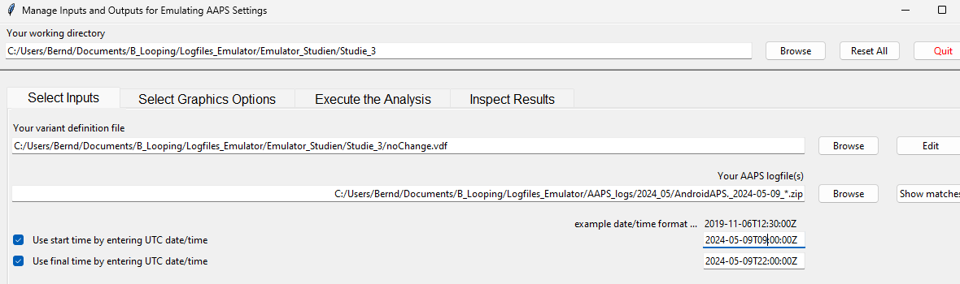
- The top box marks the path to your current emulator project (“Studie_3” is where I want to store results)
- The middle box marks the path to your current vdf (what kind of analysis; here: “…noChange.vdf” = read-only; see section 10.3 for what-if)
- The third box marks the path to your AAPS logfiles you wish to look into. A good way to do this is:
- Browse in your Windows Explorer to any logfile from the desired day (2024-05-09 in above example)
- Replace the time with an asterix * (this means you look at all-day data, in UTZ time). Check whether this will work by pressing Show matches . You should see all logfiles from that day in a pop-up info box.
- As I wanted to look at 11 am –midnight (for lunch and dinner related data), I :
  - clicked the bottom left two boxes
  - copied the date 2024-05-09 over the default date in the bottom right two data fields
  - after T (for time), I entered the desired time of analysis AFTER conversion into my local time (Central EU summer time minus 2 hours = UTZ; so to look at 11 to midnight of my AAPS screen, I must enter here 09.00:00Z, and below it 22:00:00Z).
Entries at the bottom are not mandatory, but when clicking these little boxes (bottom left) you can define a start and/or an end-point for analyzing, within the logfiles specified in the field above.

10.2.4 Press “Run emulation”.

Now we are ready to go: Press “Run Emulation”
This produces sometimes an error message (e.g. if you have a syntax error, or incompatible software versions: => seek help, in the Github materials provided by ga-zelle, or in Discord/Full-Closed-Looping/emulate-aaps here: https://discord.gg/n3tD5eXExC

What should come up after a short moment is results, which you can look into in a couple of ways.

10.2.4.1 Table of results (…noChange.csv file)

The .csv file in your project folder gives a tabular presentation of how parameters like bg, iob, iobTH, the various ISF contributors, bg target, insulinRequired etc. develop every 5 minutes, and what SMB size and %TBR resulted.
It is a vast table, so you may want to reduce it to something more “digestable”:

      - Analysis of the (date..) noChange.csv table in Excel or Libre calc.

Best copy the entire table into a new Excel or Libre office sheet, where you can:
- add right next to the standard world time your corresponding “AAPS time”
For instance, adding +2/24 translates the UTZ column into central European summer time column next to it (where currently a row of Z stands). Likewise, subtract like -5/24 from UTZ for an US East Coast time scale.
Highlight all time fields (the entire columns), and switch from hh:mm:ss format to hh:mm. (While the seconds are important for the loop’s calculations, for our comparison with Nightscout or other charts and data, it is much easier without the seconds attached)
- hide any column you find less important to look at for your intended analysis
That way, “boxes” (data fields) retain their original position in tables
Also, in case later you want to look into additional info, you can simply un-hide the relevant columns … or time lines:
- hide lines (time segments) you find less important to look at for your intended analysis

Usually you will color mark where relevant SMBs were given, which of the ISFs (and underlying weights) was strongly contributing (note that this can be good or not good) . Also where iobTH was exceeded, whether an Automation kicked in e.g. setting a TT, when there were periods with zero insulinRequired.
In section 10.3.4 we present an extra tool that does a standardized table reduction and color marking for you!

You may be able to formulate a hypothesis or two, what settings (…ISF_weights, iobTH%, SMB_range_extention, autoISFmax …) should be changed for improvement (then go to 10.3)

      - SMB tab contents in (date..) noChange.txt result file

Search options
By using the search function you can jump, in that super long list, to all places that e.g. have „autoISF“ in it or „script debug“, or „SMB disabled“ (if you want to analyze when that happened…)
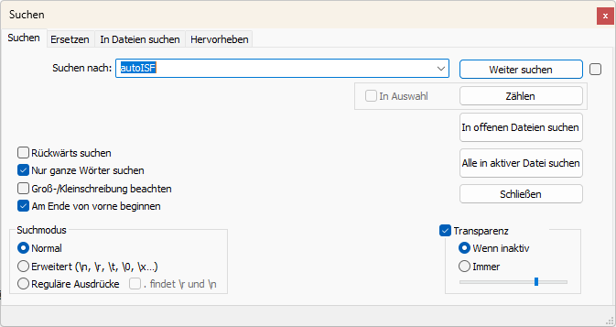

      - Graph noChange.pdf

When you open the emulator, before executing any analysis, you can make settings under “Select Graphics Options”.
Select your preferred way of outputting decimals (point or comma).
Then select whether you want “All” possible outputs in the graph, or “Most” = all except those you tick “off” in the boxes for each output parameter.
If you would use “Some/just a few”, you would have to tick those few you that do want to see, by ticking the corresponding boxes.
Recommendation is to look at (nearly) everything offered (as your default setting that you can leave untouched in most of your emulator runs):
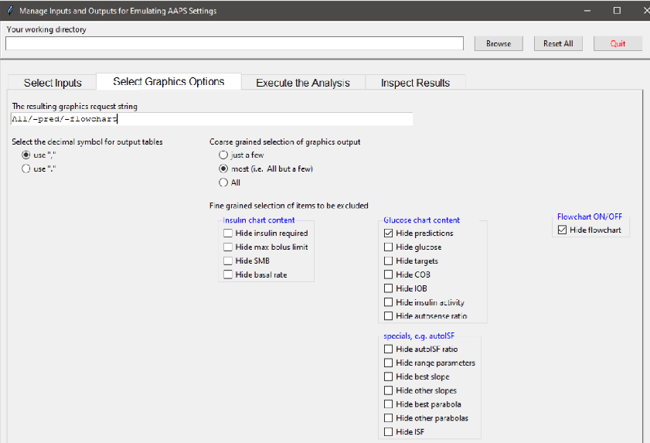

After your emulation run, under Inspect Results, you can open the pdf file that is last in the results list offered.

This noChange.pdf is a chart that shows along the time axis (down), from right to left:
- Red: the bg curve
- Yellow: the bg target (note that I do no manual “EatingSoonTT” but for bg rises over +10 mg/dl I have an Automation that sets low TT for a couple of minutes)
- Light blue corridor: Left edge is set iobTH, and bandwidth +30% (would be +20% at elevated TT)
- Dark blue line: iob (exceeding twice the iobTH, with temp. SMB shut-off
As bg did not convincingly come down enough, one could hypothesize that iobTH should be elevated. ((But, again, this would have to be confirmed also with other kinds of meals)).
- Thin yellow line: Insulin activity
- Green dotted line: ISF as would result from AAPS w/Autosens
- Green scatter points: autoISF ISF no Chage (lighter points) or what-if (darker points)
- Black line: Profile ISF
- Gray scatter points: ISF weakened (to the left of black line) or strengthened (to the right)
- Orange line: cob=0 at all times (in FCL)
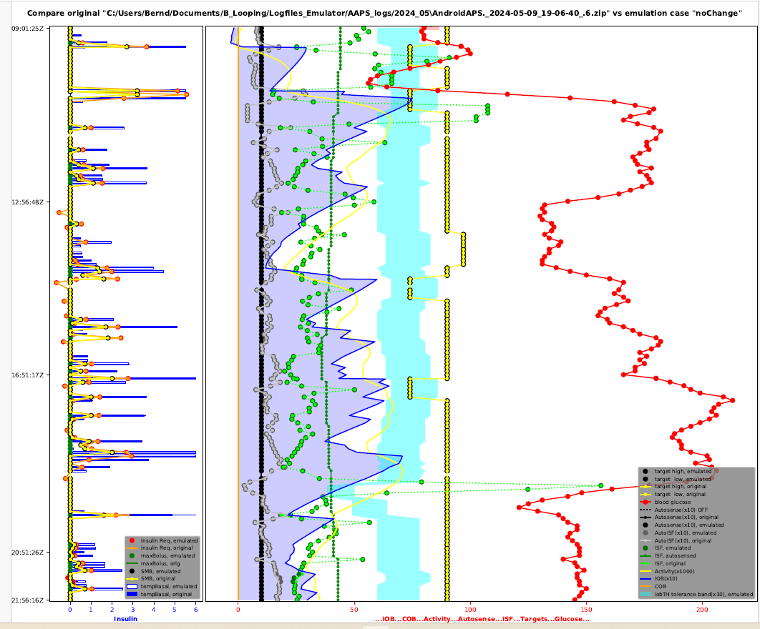
Chart with blue peaks on the left side:
(to be explained later)

  - “What-if” analysis using the emulator

In the following you see an example how you can analyze a day of logfiles, and selecting the time span of interest, for instance 11-24 h to look at how autoISF managed lunch and dinner.

You have to go through the emulator twice. You already did it (section 10.2.) using the no change.vdf, and now start over with the same emulator with your (desired changes).vdf. Repeat, if you have two or more such vdf defined. (Just clear results before executing analysis each time. No worries, all results are automatically captured for all runs, all in your selected study file).

10.3.1 Define your investigated changes in a, or in several, (your changes).vdf

Define for which one to max three parameters in your current profile settings you want to look into a different setting. Recommendation is to use a factor, like for example current setting * 0.9 , or current setting * 1.2, and use that in your naming for this vdf file, too.

Within the same study, you can make several runs with several vdf files.
All results, like the csv results table, will appear then several times in your study file, only with different name endings as in the underlying vdf.

Example: I like to check in my actual data (they are in my noChange.vdf emulator run), in which time points the following parameter changes would make a (how) big difference in the loop’s decision:
- 20% higher bgAccel_ISF_weight to boost the first SMBs stronger: How would that tend to ramp up early iob; and might that get too strong in other parts of the data? Or does it bounce into a restriction (maxSMB size; autoISFmax; iobTH…) that I might need to widen?
- Doubling my cautiously set bgBrake_ISF_weight shall give me insight into the workings of that parameter (and whether using a much smaller weight than for bgAccel_ISF_weight is really what I should keep doing)
- As my bg came down from a persistent high quite slowly, I elevate the dura_ISF by 20%
Actually, it would make more sense to first find my “optimal”, maybe indeed elevated, bgAccel_ISF_weight. Then, do a noChange run with that and a (myChanges) run with the stronger dura weight, investigated on that basis. Reason: A better job with bg control via bgAccel_ISF will reduce the peak height and provide a different (easier) scenario for dura_ISF to manage.

Now, to write your (myChanges). vdf for the emulator (this is same procedure as you did in section 10.2.1 for the noChange.vdf):

- just open Notepad++ (from list of all programs on your PC) to create a new vdf.
Alternatively you can also take another pre-existing vdf file, and copy it into your current project giving it a new name (re-name it)
- name your vdf (in our example: 1.2_bgAccel_2.0_bgBrake_1.2_dura.vdf) …
- … and store that in a file of your current emulator project you are about to start (see my storage path in top line here)
Caution: Make absolutely sure (best by looking it up in the SMB tab, down in the profile set section) to spell each term exactly as your loop uses it (probably w/ decimal points, not comma)

- …when you make one line per parameter (separating entries with spacers->):
profile->(parameter) ->->profile[‘(parameter)’]*(factor)->->###(comment as you like)

The (your changes) .vdf should look like something like this:

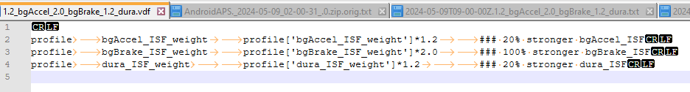
CR = LF= Erase any entries after CR LF and also any entries in lines below, if any

10.3.2 Run the emulator with (your changes).vdf

The “what-if” emulator run is done the same way as you did the noChanges run (section 10.2), however, now , the (your changes).vdf must be loaded into the 2nd input field, where formerly you had the noChange.vdf.:
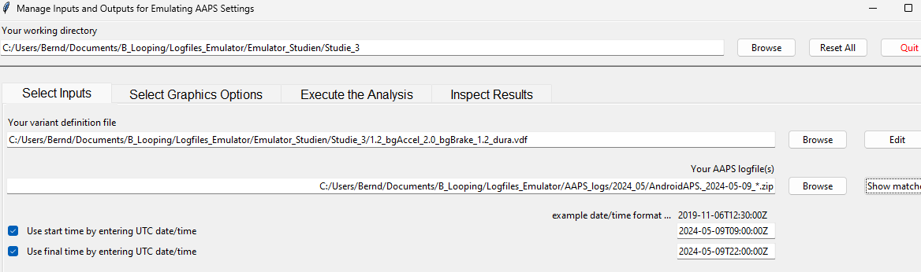

In the 3rd input field, give the path to your stored logfiles. A good way to do this is:
- Browse in your Windows Explorer to any logfile from the desired day (2024-05-09 in above example)
- Replace the time with an asterix * (this means you look at all-day data, in UTZ time). Check whether this will work by pressing Show matches . You should see all logfiles from that day in a pop-up info box.
- As I wanted to look at 11 am –midnight for lunch and dinner related data, I :
  - clicked the bottom left two boxes
  - copied the date 2024-05-09 over the default date in the bottom right two data fields
  - after T (for time), I entered the desired time of analysis AFTER conversion into my local time (Central EU summer time minus 2 hours = UTZ; so to look at 11 to midnight of my AAPS screen, I must enter here 09.00:00Z, and below it 22:00:00Z).
After making these entries, press Execute the Analysis, (evtl also Clear old Data) and then press Run Emulation, I can look the results up under “Inspect Results”:

10.3.3 Emulation results

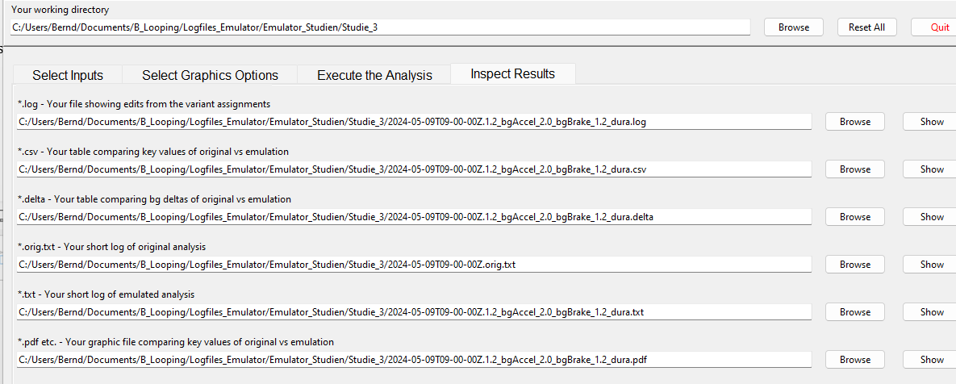
All results from your (your changes).vdf emulator go automatically where the noChange.vdf results are already stored, in our example into the “Studie 3” file, below:

Besides the 1.2_bgAccel_2.0_bgBrake_1.2_dura.vdf case which I like to look into for the present high carb meal, I also prepared another vdf that investigates a factor 1.2 stronger pp_ISF and a weaker, factor 0.8, bgAccel_ISF (with the intention to test this, and a noChange, on a low carb meal later.

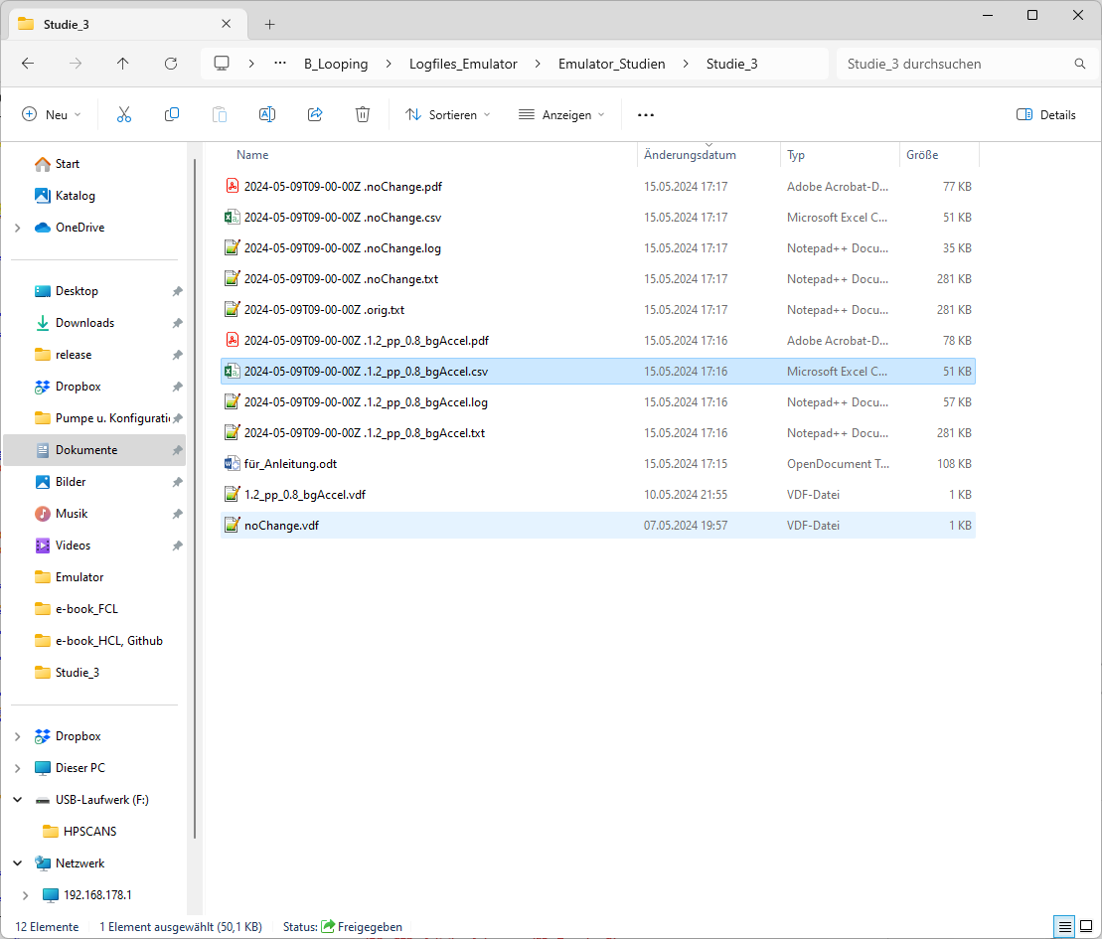
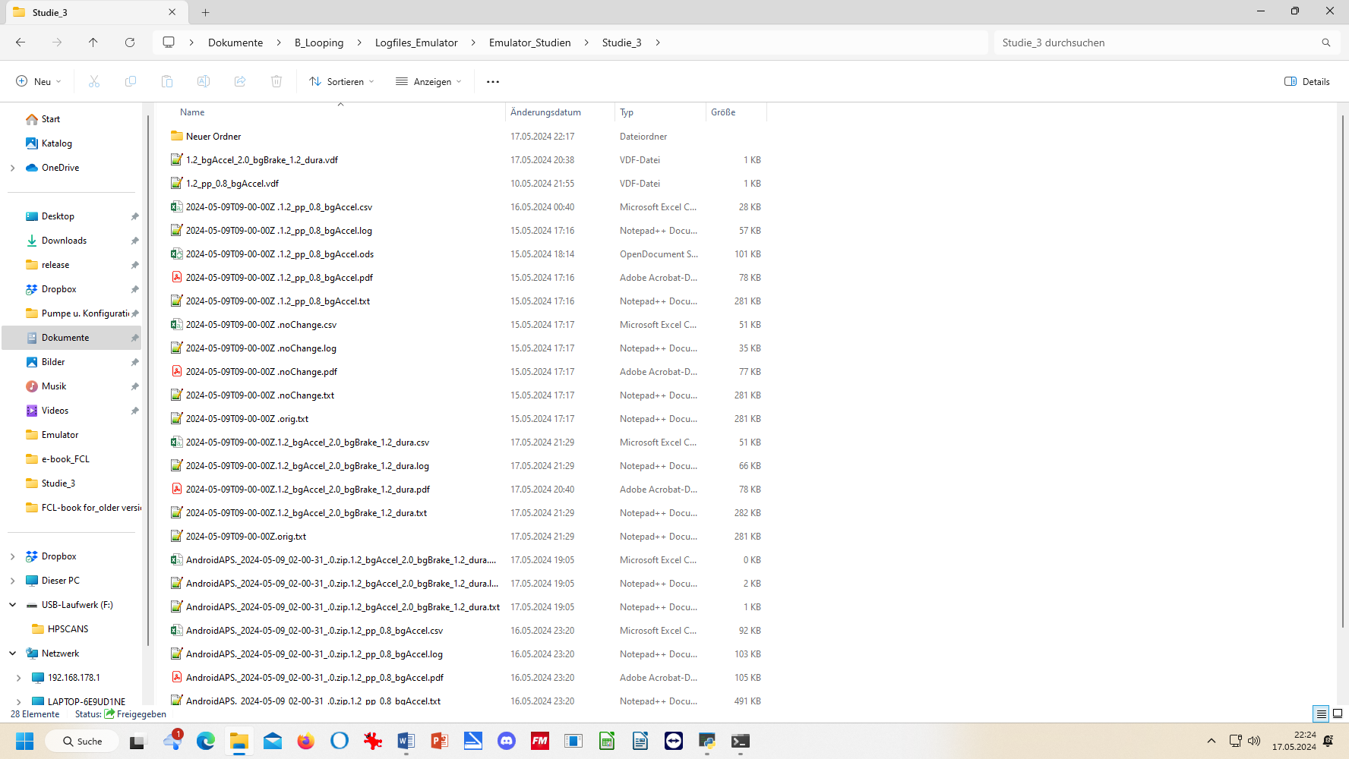
Logs

The noChange.log has all the info your series of SMB tabs had that day.
How to search in this vast list is shown elsewhere (see section 10.2.4.3 ).

Likewise, the (your changes).log gives for each loop decision in all detail how and why that decision would have changed with the different parameter inputs you are checking out here
In the two examples here, , it was a check on the difference
- a 20% stronger pp_weight and 20% weaker bgAccel_weight
- a 20% stronger weight for both, bgAccel_ and dura_ISF, and a doubling of bgBrake_weight
would make.

Note that all these “what if” data can only give rough hints, notably about the first greater change that you would see with the investigated changed setting. So it works well for investigating how to ramp up iob quickly after detection of acceleration.
However, any relevant change would put your bg curve on a different trajectory, so that would influence all following results. Therefore, what you get here is not a complete modelling how your bg would have developed in the alternative scenario.
But you can investigate in which stages the parameter(s) you are looking at in your current “what-if” had big influence, and in which direction the changes would go.
Analyzing how to safely come down from a high glucose plateau while limiting hypo danger towards the end of digestion is also to some extent possible.

A good other way to employ the what-if analysis is real time, on your smartphone, using speech synthesis (see section 11): Then you get real-time info, as to exactly when a significantly different proposal would emerge, and can decide (and watch!) real-time whether to follow the new idea and not was probably better.

Observe that a setting change must work well for you
- not just in one point of time, and
- not just for one kind of meal,
but you must look at all time slots in the investigated meal, plus analyze with the same tool a totally different meal within your usual spectrum, how things work out there

Tabular results

The noChange.csv table gives all relevant data. Besides development of bg and iob you see the calculated insulinRequired in each loop decision, and how each of the autoISF categories contributed to the decision (notably regarding SMB size).

The (your changes).csv shows in detail how every single loop decision would be influenced by the different settings you are investigating. To inspect that huge table, click on the Z behind the start UTC time entry (see black box in the Z column of the following table
If you like to see the bg in each screen, too, go 3 or 4 columns farther to the right with your black box.
Then, go to window/fix. Now you can scroll through the data and always see headline and time (or time and bg level).
To further ease analysis, feel free to temporarily erase (hide) any columns that you (think you) do not need for the intended analysis. More suggestions see in section 10.2.4.2

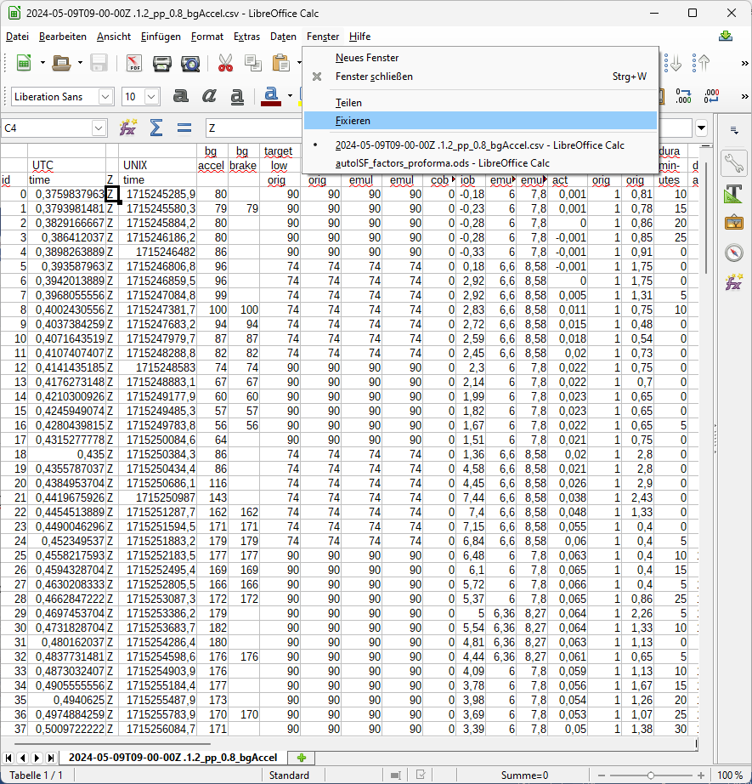

Still, the csv tables are overwhelming. You could proceed in either of two directions now:

- Convert both (or all 3) csv files into one table in Excel or into Libre office calculator. Hide columns (and eventually also lines) that are of no particular interest for your analysis. Mark differences between noChange and (yourChanges) column data with color, add extra columns with additional calculations …
This route is good to compare quantitative impacts of autoISF categories in critical time points.
- For the core data relevant to assessing your autoISF settings, there is an extra tool for convenient analysis (see next section)

    - Automated extraction from tabular results
autoISF_factors_proforma.ods is provided as an extra tool that you download from here:
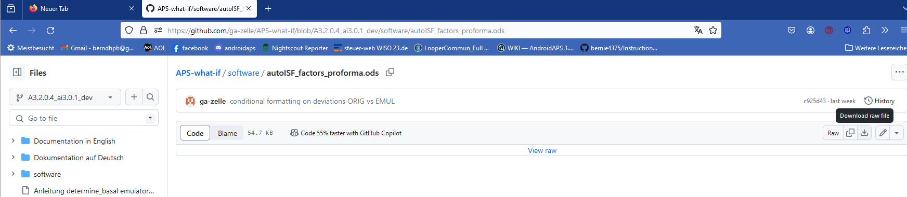
Put that file into your one level above the single files for all your studies:
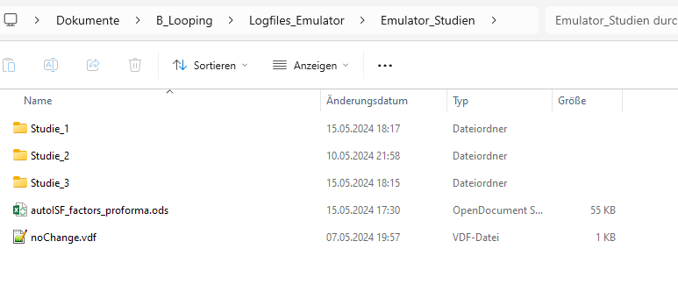
Now, if we want to use this tool on the two csv files of our Studie_3 file, we must proceed as follows (for each of the two .csv files, separately):
- Click on the .csv file and open in Libre office calculator.
- Make sure the time column is set to US_English:
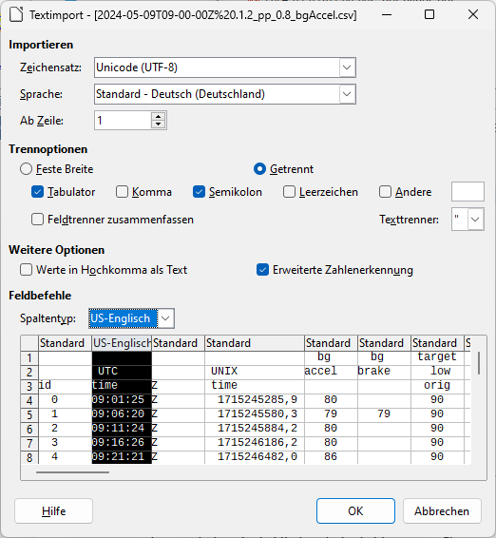

- Now start, in Libre office calculator, the autoISF_factors_proforma.ods …
This turns the first 30-some lines of your csv table (left side) into a form in which important effects are highlighted in color, and formatting is improved:
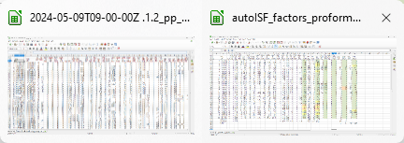

Now, you want this for the entire table.
In the autoISF_factors_proforma table, highlight 20 or more lines (not including the first or last), and mouse right hand/insert above … 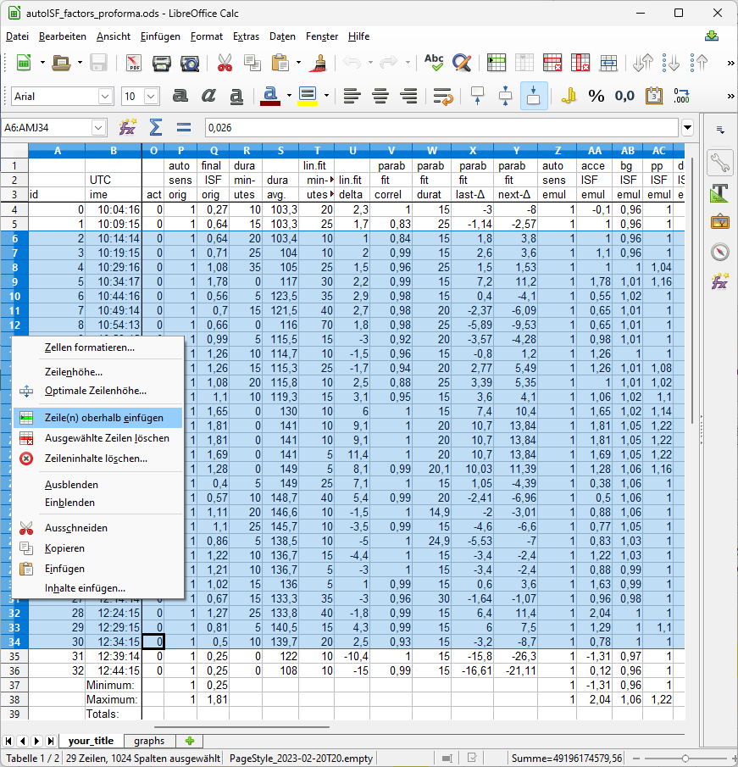

Do this as often as you need to create the number of lines that your emulated csv file comes with.
If you ended up with too many lines, erase the superfluous number (any four, in the example):
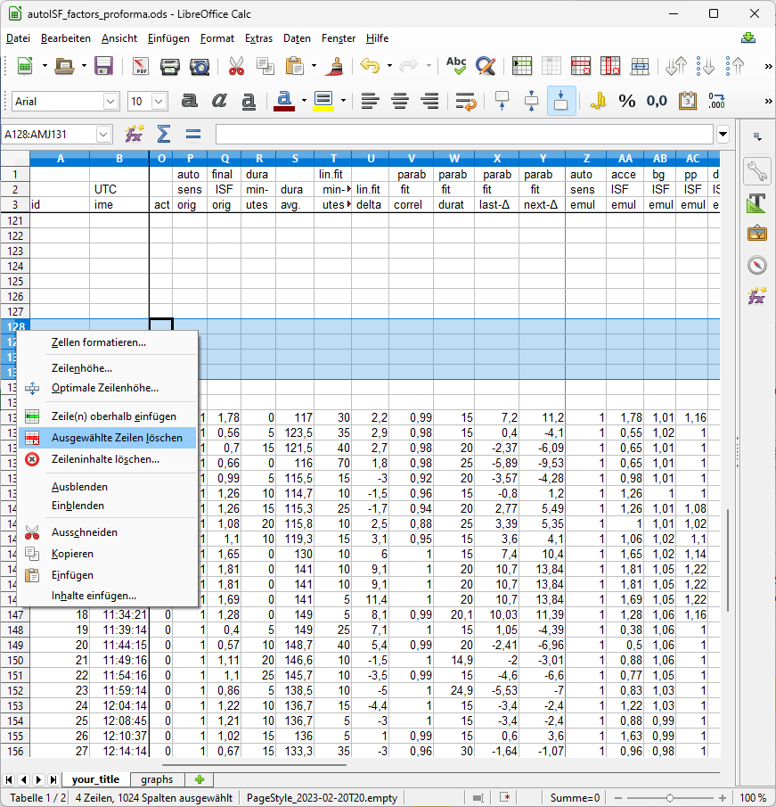
Then just copy it in, by selecting all data lines in the emulated csv, and pasting (paste special, values only) into box A4 of your “elonged” autoISF_factors_performa.ods.
The bottom tab “your_title” should be re-named by you, best with day of log you analyze, and your what-if parameters (so, the name of your csv file could be put in here)
Now you have a table with optimized lay-out that incorporates key data from both your no change AND of your investigated changes.csv files.
A super neat extra feature is already pre-programmed, which you can see if you click on the bottom tab “graphs”.
The top graph is the bg curve (the actually seen bg).
Note that for the what-if no bg development over the time range is available. (The noChange one is also given there).
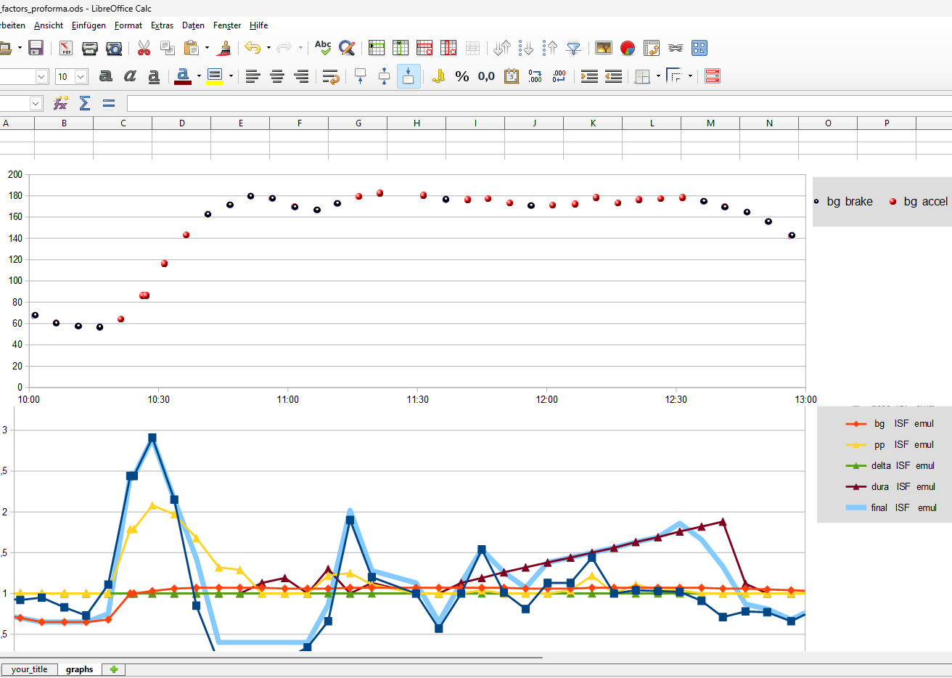
The bottom graph (do one for each, the noChange or the (yourChanges) case) shows the amplification factors coming from each autoISF category, and the overall resulting ISF amplication.
You probably have to widen the time scale (double click on the time axis, and type the desired time span (min and max UTC)(and spacing of data points, 00:30:00 or 00:15:00) into this box:
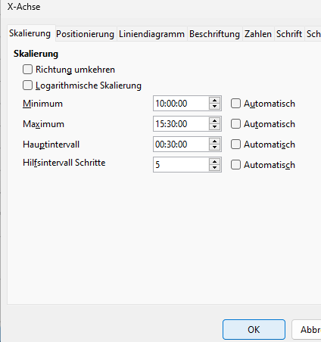
In the given example above, the 2.5 hours were not enough yet to analyze this 10:30 UTC (12:30 AAPS) lunch; we need to look until bg is near target (hopefully before dinner starts).

FCL users should first look at the initial bg rise in the noChangechart, and see how bgAccel_ISF and pp_ISF acted, or could have acted in improved ways.
The see whether yourChange idea could have contributed, or you better think of a new one.
Note that ideally we want FCL coverage of our entire “normal day” meal spectrum by one set of settings. So, not much is gained if you put a lot of effort in optimizing FCL settings for one meal. You need iterations and do such analysis for two or three very different meals that you wish the algo to automatically handle. See section 4.2/4.3 on how meals with very different carb loads might benefit or also suffer from too aggressive or to mild (category)_ISF_weights you could set.

The initial iob received might be limited by allowed SMB sizes, autoISFmax, or the (dynamic!) iobTH. You will have to look into the data table to find out about this (a quick orientation is also possible in the pdf result files you have in your project ( ) file.
Only once you found OK weights for bgAccel- and pp_ISF_weights, does it make sense to go tune the dura_ISF_weight. 12:00 – 12:45 UTC in above graph, the resulting effective ISF is dominated by dura_ISF. Just judging from the picture, a stronger weight might be worth trying. However, we really need to see the insulinRequired calculation and the further development because impatience about bringing bg values down faster too often results in hypoglycemia later.

The noChange.pdf is a chart that shows along the time axis (down), from right to left:
- Red: the bg curve
- Yellow: the bg target (note that I do no manual “EatingSoonTT” but for bg rises over +10 mg/dl I have an Automation that sets low TT for a couple of minutes)
- Light blue corridor: Left edge is set iobTH, and bandwidth +30% (would be +20% at elevated TT)
- Dark blue line: iob (exceeding twice the iobTH, with temp. SMB shut-off
As bg did not convincingly come down enough, one could hypothesize that iobTH should be elevated. ((But, again, this would have to be confirmed also with other kinds of meals)).
- Thin yellow line: Insulin activity
- Green dotted line: ISF as would result from AAPS w/Autosens
- Green scatter points: autoISF ISF no Chage (lighter points) or what-if (darker points)
- Black line: Profile ISF
- Gray scatter points: ISF weakened (to the left of black line) or strengthened (to the right)
- Orange line: cob=0 at all times (in FCL)
Chart with blue peaks on the left side: (to be explained later)
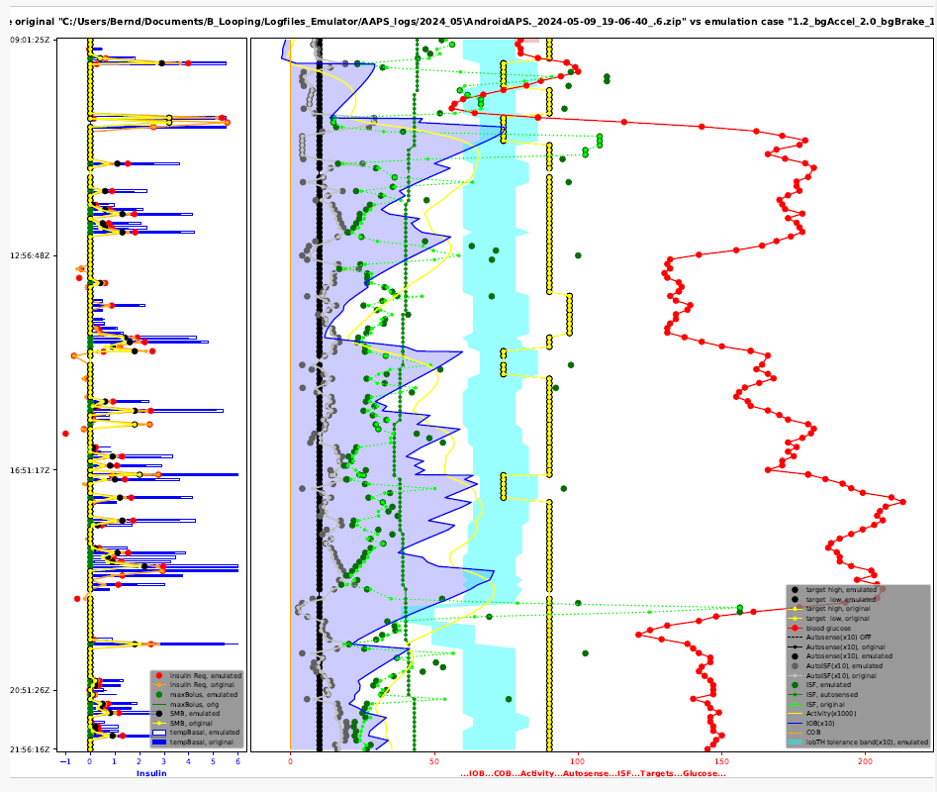
(not finished)

